LinuX Assignmeant

Find all the files that got created in the last 6 hours
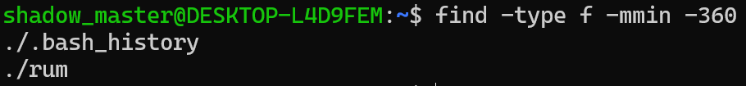

Find all the files that got created in the last 30 minutest

Find all the empty files
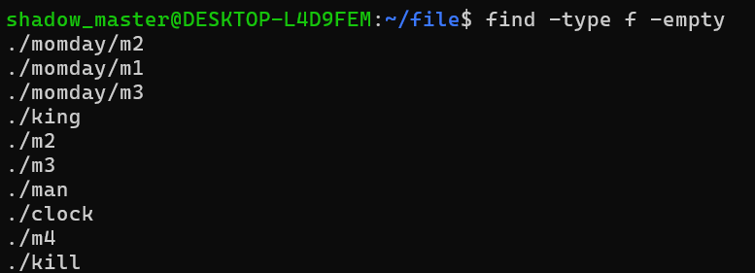

Find all the empty files and delete them

Find all the files that have a size of more than 1 MB
